Submission overview checklist

Your Name: _Christina Wise__
Date:
______01/16/2026_________

Instructions:

Copy Pseudocode Exercise 1: Compute miles per gallon here:
Start
//declare variables
Define tankSize = 0
Define milesTraveled = 0
Define milesPerGallon = 0
//prompt “How many gallons does your tank hold?”
Input tankSize
//prompt “How many miles can you drive on a tank of gas?”
Input milesTraveled
milesTraveled / tankSize = milesPerGallon
Print “Your gas mileage is “ + milesPerGallon
End

Copy Lucidchart Exercise 1: Compute miles per gallon here:
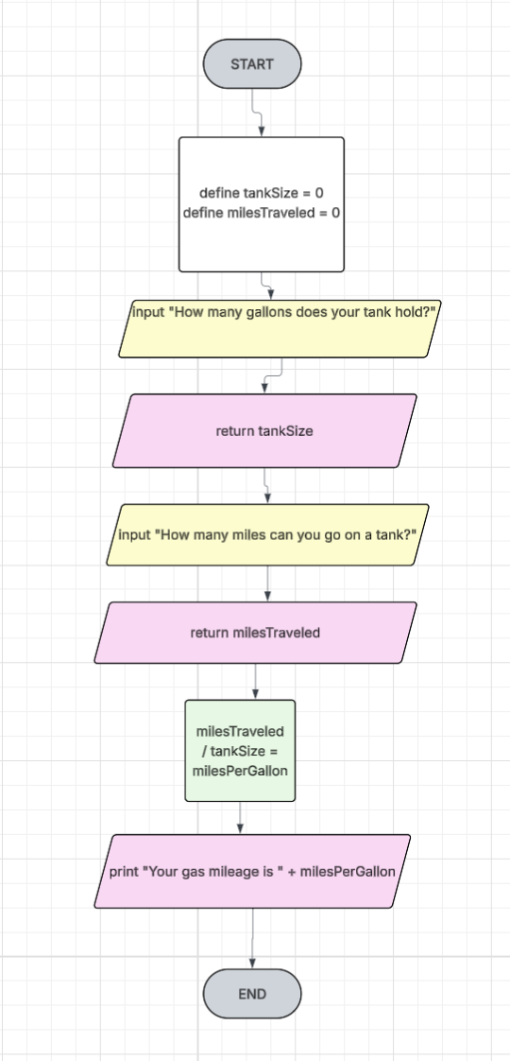
Copy Pseudocode Exercise 2: Compute daily rent costs here:
Start
//declare variables
Define monthlyRent = 0
Define totalDays = 0
Define dailyRent = 0
//prompt “How much is your monthly rent?”
Input monthlyRent
//prompt “How many days are in this month?”
Input totalDays
monthlyRent / totalDays = dailyRent
Print “Your daily rent is “ + dailyRent
End

Copy Lucidchart Exercise 2: Compute daily rent costs here:

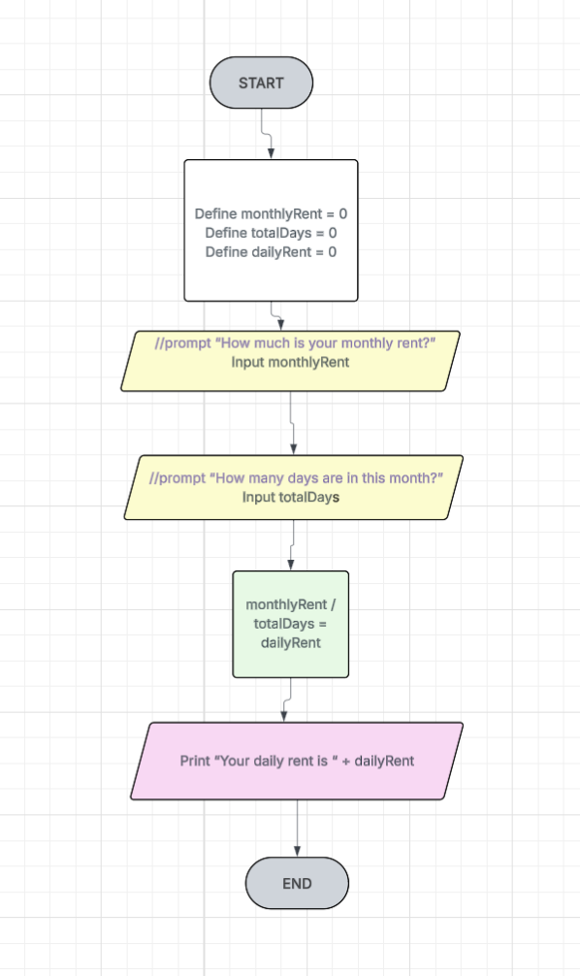

Copy Pseudocode Exercise 3: Think about a routine task or decision-making process in
your daily life here:
Start
//declare variables
Define feedingTime = 0
Define hasEaten: boolean
//prompt “Has the dog eaten dinner yet?”
If hasEaten = true
Print “The dog has already eaten.”
else
If feedingTime <= 7:30
And
hasEaten = false
Print “Time to feed the dog.”
Else
Print “Feeding time is at 7:30”
End

Copy Lucidchart Exercise 3: Think about a routine task or decision-making process in
your daily life here:
